Dear Colleagues
I wanted to let you know about free statistical consulting and new statistics seminars offered by the Institute for Statistical and Data Science (Instats). All of their seminars are discounted for PhD students, and the multi-seminar Structured Programs have a further discount. Additional details are below.

Cheers and best wishes
Mike Zyphur

Institute for Statistical and Data Science

Instats is dedicated to helping researchers tackle their data-analytic challenges by providing hands-on training and expert consulting

Featured Live Stream Seminar

Live-streaming seminars are delivered over 2 days and include interactive tutorials, discussion, and activities. To enable asynchronous learning, recordings of all sessions and instructor support are available for 30 days.

Organizational ESM Research: From Design and Analysis to Publication
July 19-20 (New York time)

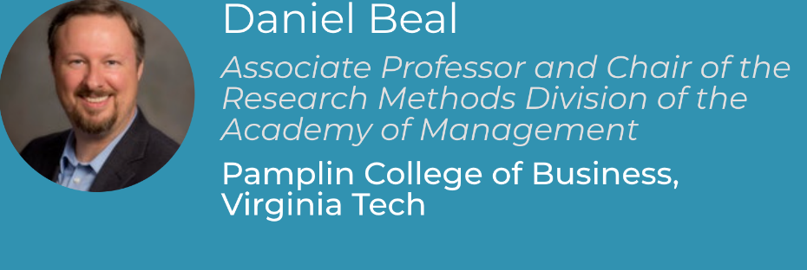

Register Now

Featured Structured Program

Structured programs offer comprehensive coverage for a range of analysis methods and software, with a 10% discount applied to each seminar in the program.

From Regression to Longitudinal and Multilevel SEM in Mplus
Consists of four 2-day live seminars taught in Mandarin (中文)

Regression and Path Analysis in Mplus
July 7-8
SEM and CFA in Mplus
July 14-15
Longitudinal SEM in Mplus
August 11-12
Multilevel SEM in Mplus
August 18-19
All seminars in this program start at 8am Beijing time

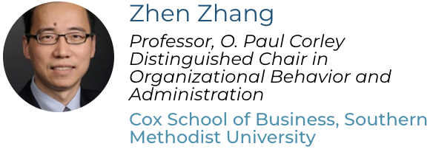

Register Now

Free Statistical Consulting

Office hours are an opportunity to get personalised support with one of our experts on a different topic each week. Office hours are free, but spaces are very limited. New office hours are typically posted at the beginning of each week.

Next up: Single-Level Modeling in Mplus
May 27 (Melbourne Time)

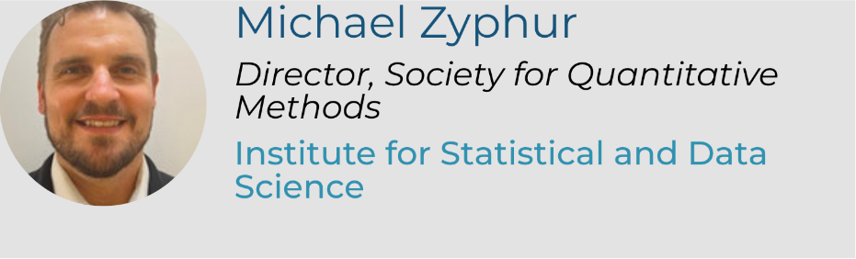

Register Now

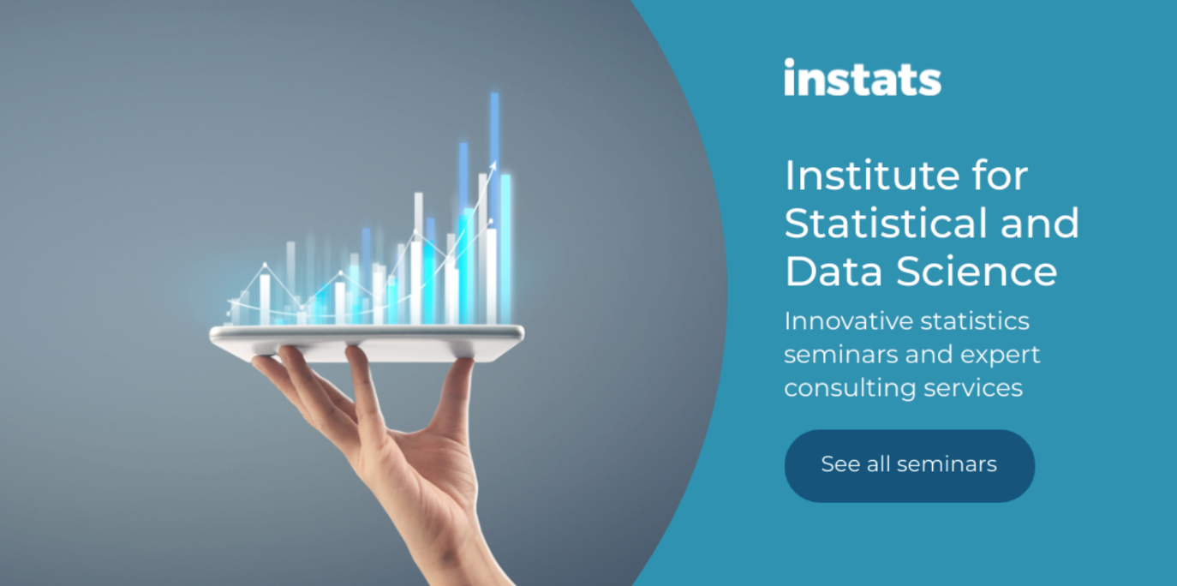
Unsubscribe

